**ABSTRACT**

Glaucoma is an eye disease caused by elevated intra-ocular pressure. This elevated pressure destroys the optic nerve. Your eye constantly makes aqueous humor. As new aqueous flows into your eye, the same amount should drain out. Glaucoma is caused by increased fluid pressure on the optic nerve leading to irreversible, permanent blindness. Early detection is essential to prevent loss of vision. In this project, automated detection of glaucoma using optic disk and optic cup using deep learning/machine learning techniques. In this work, a baseline ResNet50 will be trained, evaluate the model, and use SHAP model explainability technique to help us better understand our model's predictions, and how we could further improve its performance. SHAP (Shapley Additive explanation) is a game theoretic approach to explain the output of any machine learning model. It connects optimal credit allocation with local explanations using the classic Shapley values from game theory and their related extensions. The result obtained with deep learning based ResNet50 model and the accuracy obtained is 99.04%.

**CHAPTER-1**

**INTRODUCTION**

Glaucoma is an eye disease caused by elevated intra-ocular pressure. This elevated pressure destroys the optic nerve. Your eye constantly makes aqueous humor. As new aqueous flows into your eye, the same amount should drain out. The fluid drains out through an area called the drainage angle. This process keeps pressure in the eye ( i.e called as intra ocular pressure) stable. But if the drainage angle is not working properly, fluid builds up. Pressure inside the eye rises, damaging the optic nerve.

Some people have a higher than normal risk of getting glaucoma

* Are over age 40,
* Have family members with glaucoma,
* Have high eye pressure,
* Are farsighted or nearsighted,
* Have had an eye injury,
* Use long-term steroid medications,
* Have diabetes, migraines, high blood pressure, poor blood circulation or other health problems affecting the whole body.

The estimated prevalence of glaucoma cases in India is reported to be 11.9 million. This prevalence of glaucoma in India is not the same at every place, with varying prevalence among different populations and subgroups having rate of being 2.3 – 4.7%.

SYMPTOMS:

* + Severe pain in the eye or forehead
  + Redness of the eye
  + Decreased vision or blurred vision
  + Headache
  + Nausea
  + Vomiting

There are two main types of glaucoma:

1. Primary open-angle glaucoma

With open-angle glaucoma, there are no warning signs or obvious symptoms in the early stages. As the disease progresses, blind spots develop in your peripheral (side) vision.

2. Acute angle-closure glaucoma

People at risk for angle-closure glaucoma usually show no symptoms before an attack. Some early symptoms of an attack may include blurred vision, halos, mild headaches or eye pain.

* Glaucoma damage is permanent—it cannot be reversed. But medicine and surgery help to stop further damage.

The aim of the proposed system is to build a deep learning model for detection of Glaucoma and implement Explainability technique to help us better understand our model's predictions.

The main advantage of the proposed system is that is a less expensive alternative to the existing glaucoma detection tests like tonometry, pachymetry, gonioscopy, and imaging tests to show the retina nerve fiber damage. These tests can be expensive and some hospitals may not possess the necessary equipment to perform the tests. Hence, newer, less expensive techniques to detect glaucoma in early stages are required to identify those at risk, in the early stages of the disease, so that an ophthalmologist can monitor the progression of the disease and provide proper treatment.

* 1. **MOTIVATION:**

Glaucoma remains the leading cause of blindness, despite the availability of treatments. Early detection can help prevent permanent vision loss due to glaucoma. Hence progress in the development of deep learning algorithms that would quickly and accurately identify glaucomatous damage on diagnostic tests can contribute to the prevention of optic nerve damage and blindness due to glaucoma.

* 1. **PROBLEM STATEMENT**

Explainability technique to help us better understands our model's predictions, and how we could further improve its performance. Automated detection of glaucoma using deep learning technique Resnet50. An implementation of Deep SHAP, deep learning models that is based on connections between SHAP and the DeepLIFT algorithm.

* 1. **APPLICATIONS**

Glaucoma is the leading cause of irreversible blindness and disability worldwide. Nevertheless, the majority of patients do not know they have the disease and detection of glaucoma progression using standard technology remains a challenge in clinical practice. Artificial intelligence (AI) is an expanding field that offers the potential to improve diagnosis and screening for glaucoma with minimal reliance on human input. Deep learning (DL) algorithms have risen to the forefront of AI by providing nearly human-level performance, at times exceeding the performance of humans for detection of glaucoma on structural and functional tests. The glaucoma detection system developed can be a faster, cost-effective diagnosis of glaucoma can be provided in early stages. An ophthalmologist can use the model to detect glaucoma before a specialist can perform tests.

1.**4 OBJECTIVES AND SCOPE OF THE PROJECT**

The main objective of the system is to detect any presence of glaucoma in the fundus image. But to detect glaucoma effectively is the key. Hence some of the objectives that help in effective detection are discussed in this section.

* + 1. **OBJECTIVES**
  1. To build deep learning model ResNet50 and classify input fundus image according to the respective categories. (2 categories: Glaucoma, Non-glaucoma).
  2. To provide explanations to the fundus image using explainable AI model.
     1. **SCOPE OF THE PROJECT**

Proposed system can be used as an application so that it can recognize the images and prevent Glaucoma. Glaucoma detection can help doctors to detect glaucoma eye disease easily based on the models which give accurate results and also in understanding the cause of Glaucoma detection. The system could bring improvements in ophthalmology, such that the ophthalmologist can detect glaucoma before a glaucoma specialist can perform the eye examination for glaucoma diagnosis which can be expensive and time consuming. The system can also process different formats of fundus images i.e., .tif, .jpeg or .png formats.

**CHAPTER 2**

**REQUIREMENT ANALYSIS**

**2.1 FUNCTIONAL REQUIREMENTS**

The system’s primary objective, as discussed, is to detect the presence of glaucoma in the fundus image. The section describes what the system should do to detect glaucoma.

System

• System shall be able to classify the fundus images into glaucoma and non-glaucoma classes.

• System shall be able to pre-process images as required by models.

• System shall be able to extract textural features from the fundus images.

**2.2 NON FUNCTIONAL REQUIREMENTS**

The non-functional requirements describe mainly the performance of the system, quantifying them.

• The system should be able to grade a new input image.

• The input image should be a colour fundus image belonging to one of the two classes.

**2.3 HARDWARE AND SOFTWARE REQUIREMENTS**

In addition to the functional and non-functional requirements as discussed in sections 2.1 and 2.2 respectively, below are a few hardware and software requirements of the project.

* A machine with significant RAM and GPU to process input and run the models.
* The system utilizes the feature sub-module in the ImageNet.
* An implementation of Deep SHAP, deep learning models that is based on connections between SHAP and the DeepLIFT algorithm.

**CHAPTER 3**

**SYSTEM DESIGN**

In this chapter, the suitable architectural framework for the glaucoma detection and the further design of the system is discussed.

**3.1 ARCHITECTURAL FRAMEWORK**

The architecture framework of the glaucoma detection system can be that of a segmentation, in which the fundus images (data) go through the stream of different modules represented as filters.

On classification, the performance of the model is to be tested and validated. If suitable results are not obtained, feature extraction is revisited to identify the significant features to give the result of glaucoma or non-glaucoma.

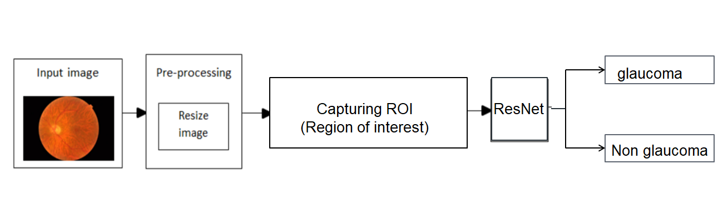

ResNet50

Fig 3.1: Architecture of deep learning technique

The above fig 3.1 explains that the model will be given the input fundus image for pre-processing where the image will be resized where the image data will be trained with the ResNet50 model. After training the image dataset it will be tested by two categories glaucoma and non-glaucoma.

**CHAPTER 4**

**IMPLEMENTATION**

In this chapter, the resnet50 model will be discussed and SHAP explainability technique will be used for better predictions of the Image dataset.

**4.1 FEATURE EXTRACTION**

Texture is used in many computer vision systems as a key element. Texture is defined as a measure of coarseness, contrast, directionality, like-likeness, regularity, and roughness. The texture can also be seen as a similarity grouping in an image or as natural scenes containing semi-repetitive arrangements of pixels. In features include colour, texture and shapes in the image.

**4.2 RESNET 50**

Resnet50 is a pre-trained Deep learning model. A pre-trained model is trained on a different task than the task at hand and provides a good starting point since the features learned on the old task are useful for the new task. Deep Neural networks have a large number of unknown parameters. To find all the unknown parameters would require lots of data (in millions). It is very difficult to get such large labelled dataset. Instead we leverage models that have already being trained on very large amounts of data for difficult task with thousands of classes.ResNet-50 is a convolutional neural network that is 50 layers deep. You can load a pretrained version of the network trained on more than a million images from the ImageNet database. The pretrained network can classify images into 1000 object categories. Keras comes bundled with these models and so we are using one of these models in this sample. We have used image size or target size as **(224, 224),** batch size as **32**, and trained the dataset for 15 epochs and found the test accuracy of **99.41%** and validation accuracy as **95.86%.**

**4.3 EXPLAINABLE AI**

Explainable AI is an emerging field in machine learning that aims to address how black box decisions of AI systems are made. This area inspects and tries to understand the steps and models involved in making decisions. Little visibility and knowledge on how AI systems make the decisions they do. The lack of explainability and trust hampers our ability to fully trust AI systems. One way to gain explainability in AI system is to use machine learning algorithms that are inherently explainable. Simpler forms of machine learning algorithms will have certain amounts of traceability and transparency. SHAP (SHapley Additive exPlanations) is a game theoretic approach to explain the output of any machine learning model. It connects optimal credit allocation with local explanations using the classic Shapley values from game theory and their related extensions. Shap is used for explaining machine learning models with Shapley values. Shapley values are a widely used approach from cooperative game theory that comes with desirable properties. We have used some model parameters, i.e. Batch size as 8,to fine tune the complete model we use 20 Epochs history_ fine-tuning and for history_warmup we use Warmup epochs as 2, Height as 224, width as 224, Canal as 3.In this model expected gradient combines ideas from Integrated Gradients, SHAP into a single expected value equation. This allows an entire dataset to be used as the background distribution and allows local smoothing. If we approximate the model with linear function between each background data sample and the current input to be explained, and we assume the input feature are independent then expected gradients will compute approximate SHAP values.

**CHAPTER 5**

**RESULTS AND DISCUSSIONS**

In this chapter, the results of the implementation methodology and the Explainable AI model will be discussed.

**5.1 DATASET DESCRIPTION**

The data utilized from an open source Kaggle dataset is used as an input for DR and RIGA dataset is used as an input for Glaucoma. The dataset has a total of 2664 images among which 1488 images are non-glaucomatous and 1176 images are glaucomatous.We will use 70% of the image data set for training our model and left 30% for testing the model.

Some sample images from the dataset can be seen in figure 5.1. The first four of fundus images are of normal healthy retinal images i.e., non-glaucomatous and the second four images are of glaucomatous.

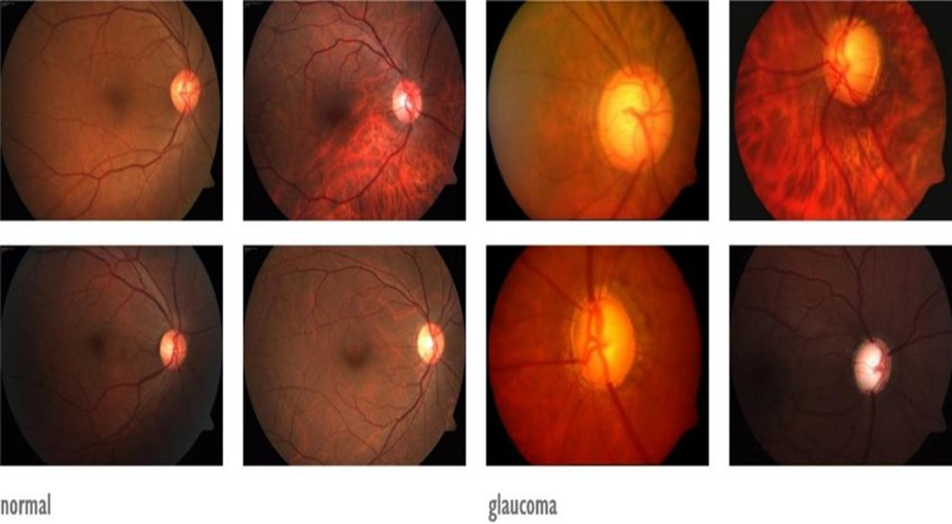

Fig 5.1: Sample images from the dataset

The images in figure 5.2 show possible glaucomatous signs in the optic disc region. The image (a) shows optic disc haemorrhage and image (b) shows optic nerve damage. Both these defects can cause permanent vision loss due to glaucoma.

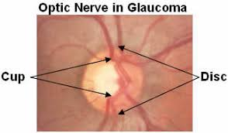

Fig 5.2: Optic nerve in Glaucoma

The entire dataset itself is split as training, validation and testing datasets.

**5.2 CLASSIFICATION RESULTS**

In this section results of Explainability technique to help us better understand our model's predictions, and how we could further improve its performance will be discussed.

**5.3 RESNET50**

ResNet50 which has 50 layers is chosen for comparison with textural extraction technique. The pre-trained version of ResNet50 has been trained over ImageNet dataset with over 1000 classes.

The dataset is split into training and validation subsets with 70-30 split ratio. The model is then trained and validated for 15 epochs with batch size of 32. With ’Adam’ optimizer, the training accuracy was found to be 99.41% and validation accuracy was 95.86% and the training and validation loss is found to be 0.0443 and 0.1131 respectively.

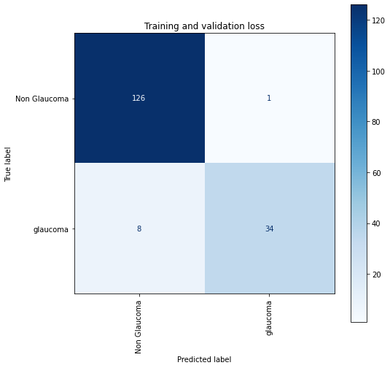

Fig 5.3: Confusion matrix of resnet50

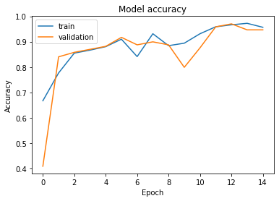

Fig 5.4: Training vs. Validation accuracy

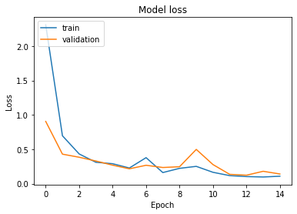

Fig 5.5: Training vs. Validation loss

**5.4 SHAP EXPLAINABILITY TECHNIQUE**

An implementation of expected gradients to approximate SHAP values for deep learning models. It is based on connection between SHAP and the integrated Gradient algorithm. Deep SHAP is a high-speed approximation algorithm for SHAP values in deep learning models that builds on a connection with DeepLIFT described in the SHAP. The implementation here differs from the original DeepLIFT by using a distribution of background sample instead of a single reference value, and using Shapley equations to linearize components such as max, softmax, products, division, etc. note that some of these enhancements have also been since integrated into DeepLIFT. Tensor flow models and keras models using the tensor flow backend are supported.

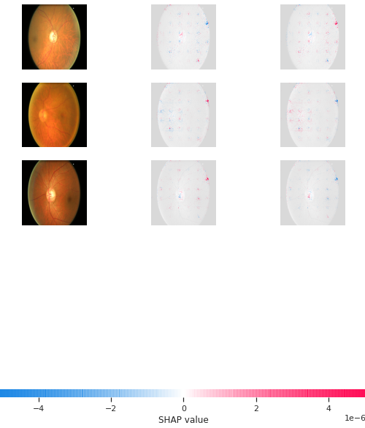

Fig 5.6: SHAP explainable images

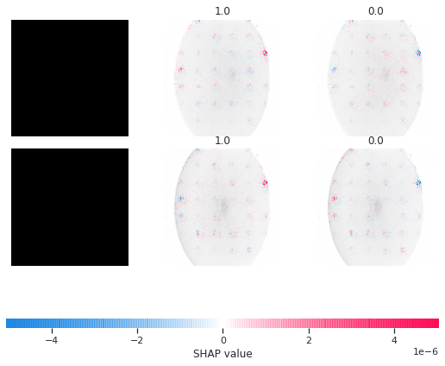

Fig 5.7 feature attribution of predictions of the model

* The plot above explains outputs (levels of glaucoma) for three different images. Positive SHAP value increases the model's output while negative SHAP value decreases the output. The input images are shown on the left (they are black because most of the pixels are greater than 0), and as nearly transparent grayscale backings behind each of the explanations. The sum of the SHAP values equals the difference between the expected model output (averaged over the background dataset) and the current model output.
* Note that for the images that the label is greater than Zero that is positive SHAP value.
* Labels that have higher positive SHAP values as the correct one are labels that our model probably doesn't have a high confidence prediction.

**CHAPTER 6**

**CONCLUSION AND FUTURE SCOPE**

In this project, an approach for glaucoma detection based on textural feature extraction was implemented. The key differences between the existing method of optic disc segmentation for glaucoma detection and the approach here are, firstly, the classification does not rely solely upon the cup-to-disc ratio but focuses on the texture of the entire fundus image. The deformation caused in the optic nerve as well as in the entire retina background was taken into account for texture analysis. The model was able to successfully classify images into glaucomatous and non-glaucomatous classes. The results obtained with deep learning based ResNet50 model is of 99.41%. And Deep SHAP is a high-speed approximation algorithm for SHAP values in deep learning models that builds on a connection with [DeepLIFT](https://arxiv.org/abs/1704.02685) described in the SHAP NIPS paper. The implementation here differs from the original DeepLIFT by using a distribution of background samples instead of a single reference value, and using Shapley equations to linearize components such as max, softmax, products, divisions, etc.

In future, more types of textural feature extraction techniques like HOG (Histogram of Oriented Gradients) and SIFT (Scale-Invariant Feature Transform) can also be adopted. The model also can be deployed onto an edge device which can be attached to a specialised camera to capture the fundus images which is the input to the model, and hence possible glaucoma can easily be detected.

**REFERENCES**

1. Dr. Shantala Giraddi and Dr.Jagadeesh Pujari, Ph.D., Identifying Abnormalities in the Retinal Images using SVM Classifiers, International Journal of Computer Applications (0975 – 8887) Volume 111 – No 6, February 2015.
2. Dr. Shantala Giraddi#1, Dr.Jagadeesh Pujari, Abnormality Detection in retinal images using Haar wavelet and First order features, 978-1-5090-2399-8/16/$31.00 c 2016 IEEES.
3. Amitojdeep, Sourya Sengupta, and Vasudevan Lakshminarayanan. 2020. "Explainable Deep Learning Models in Medical Image Analysis" Journal of Imaging 6, no. 6: 52.
4. Amann, J., Blasimme, A., Vayena, E. et al. Explainability for artificial intelligence in healthcare: a multidisciplinary perspective. BMC Med Inform Decis Mak **20,**310 (2020).
5. U. Pawar, D. O’Shea, S. Rea and R. O’Reilly, "Explainable AI in Healthcare,"2020 International Conference on Cyber Situational Awareness, Data Analytics and Assessment (CyberSA)*,* 2020, pp*. 1-2,* doi: 10.1109/CyberSA49311.2020.9139655.
6. Suvajit Dutta et al,. “Classification of Diabetic Retinopathy Images by Using Deep Learning Models” International Journal of Grid and Distributed Computing Vol. 11, No. 1 (2018), pp.89-106 <http://dx.doi.org/10.14257/ijgdc.2018.11.1.09>.
7. J. Rebane, I. Samsten, P. Pantelidis and P. Papapetrou, "Assessing the Clinical Validity of Attention-based and SHAP Temporal Explanations for Adverse Drug Event Predictions," 2021 IEEE 34th International Symposium on Computer-Based Medical Systems (CBMS)*,* 2021, pp. 235-240, doi: 10.1109/CBMS52027.2021.00025.
8. Z. Gao, J. Li, J. Guo, Y. Chen, Z. Yi and J. Zhong, "Diagnosis of Diabetic Retinopathy Using Deep Neural Networks," in IEEE Access, vol. 7, pp. 3360-3370, 2019, doi: 10.1109/ACCESS.2018.2888639.
9. M. T. Islam, H. R. H. Al-Absi, E. A. Ruagh and T. Alam, "DiaNet: A Deep Learning Based Architecture to Diagnose Diabetes Using Retinal Images Only," in IEEE Access, vol. 9, pp. 15686-15695, 2021, doi: 10.1109/ACCESS.2021.3052477.
10. C. Shetty and P. Gutte,” A Novel Approach for Glaucoma Detection Using Fractal Analysis”, 978-1-5386-3624- 4/18/$31.00 c 2018 IEEE.
11. A. Bashar, “Survey on evolving deep learning neural network architectures”, Journal of Artificial Intelligence and Capsule Networks (2019) Vol.01/ Issue.02 Pages: 73-82 http://irojournals.com/aicn/ DOI: <https://doi.org/10.36548/jaicn.2019.2.003>.
12. Shapley sampling values: Strumbelj, Erik, and Igor Kononenko. "Explaining prediction models and individual predictions with feature contributions." Knowledge and information systems 41.3 (2014): 647-665.
13. DeepLIFT: Shrikumar, Avanti, Peyton Greenside, and Anshul Kundaje. "Learning important features through propagating activation differences." arXiv preprint arXiv:1704.02685 (2017).
14. L. Li, M. Xu, H. Liu, Y. Li, X. Wang, L. Jiang, Z. Wang, X. Fan, and N. Wang, “A Large-scale Database and a CNN Model for Attention-based Glaucoma Detection”, IEEE Transactions On Medical Imaging,2019, 1-11.
15. A. Serener and S. Serte, “Transfer Learning for Early and Advanced Glaucoma Detection with Convolutional Neural Networks”, 978-1-7281-2420-9/19/ 2019 IEEE.